Making of Document GD S3

MAKING OF GAME DESIGN SEMESter 3

Damian van Veldhoven

2018

Inhoud

Fase 1 – Concept 1

Mechanics 1

Dynamics 1

Aesthetics 1

Fase 2 – Design 1

Mechanics 1

Dynamics 6

Aesthetics 6

Fase 3 – Deliverable 7

Mechanics 8

Dynamics 10

Aesthetics 11

Sources 14

# Fase 1 – Concept

Since the genre of the game was tower defense Tim and I decided to work together. A story was needed to justify the style of the game so we thought up a story that involved a kingdom that is surrounded by darkness. This kingdom has to fend of the darkness that’s relentlessly trying to breach the kingdom, which is protected by 3 towers which are connected with walls.

## Mechanics

Because it’s a tower defense we wanted players to be able to buy and upgrade towers, but to switch it up we also wanted to add a tower that you could shoot yourself. Towers can attack mobs that come close. These mobs move in a single file line through the map in a preset route, which can be dynamically changed for future maps. These mobs damage the King’s tower when they reach it, and grant gold to the player when killed. This gold can be used for towers and upgrades. A generator is available to be build on the map which will generate Crystala over time. When the player reaches a certain amount, the game is won. If the player loses all health, the game is lost.

## Dynamics

We wanted strategies in our game so we decided that towers can only attack certain type of mobs.   
Also we wanted projectiles to do different thing so quickly we decided on projectiles like snowballs to slow and bombs to do area of effect damage. The towers are to have upgrades like damage, range and firing speed so that players can decide what’s best for certain towers. The king’s tower has a target that can be moved around the map, so players can focus the damage on a specific area.

## Aesthetics

Since I am good with pixel art we decided to put that to use and make the game pixelated. We want to have a light and darkness color difference between the player’s towers and mobs, and the map to correspond to that, to fit to the story that we made up. The shop menu is going to be on the right, whilst the map is going to be on the left. This is based off of the Bloons franchise. The shop will have a towers and abilities tab, and when a tower on the map is selected the upgrade UI will cover the shop.

# Fase 2 – Design

## Mechanics

For the towers we made a class diagram (Figure 1) to make sure we could expect everything to work fine In the future. This class hierarchy allows us to add specific towers for certain needs. Once the towers scripts were done, we continued making the ballista tower (Figure 6). This tower is able to shoot mobs close to it, and can be upgraded when an upgrade menu is added.

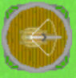

Figure 6

The mobs were added as prefabs which can have their value’s changed, and work with a very similar hierarchy as Figure 1. The mobs have scripts that allow them to follow a preset set of nodes, so that It can be simulated that they follow a path (Figure 2).

All scenes are linked so that a starting screen now sends the player to a level selector, and then the level selector sends the player to the game.

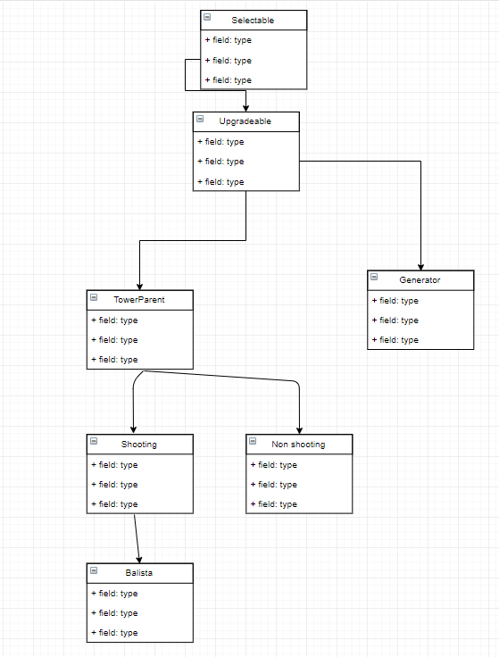

Figure

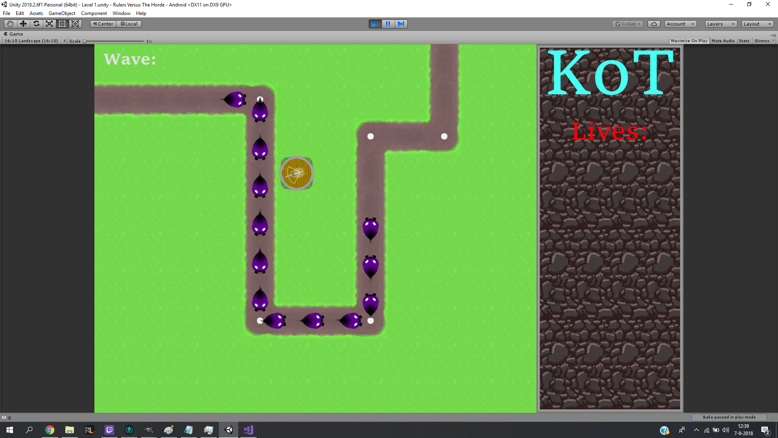

Figure 2

The King’s tower is added with the targeting system. The target can be moved when a finger is slid over it. (figure 3).

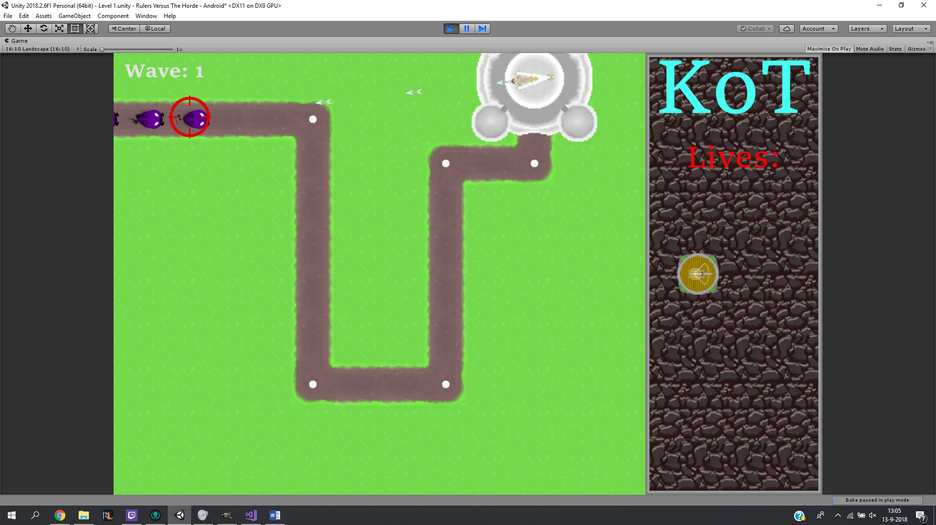

Figure 3

The Crystala mechanic is added into the code, and the bar for it has been added to the top-middle of the screen (Figure 6). Currently it just fills out automatically and doesn’t do anything, this is due to the generator not being finished yet. I used a Youtube video to gain inspiration and info on how to make the bar Source 1.



Figure 6

A grid mechanic was added to the placement of the towers, because we didn’t want to allow the player to place towers wherever he liked. Because the map is made up off 64x64 pixel tiles, we also wanted the player to only be able to place on those tiles, hence the system. The red over the King’s tower and the path are a visual aid to the player to show where the towers can and cannot be build (Figure 8).

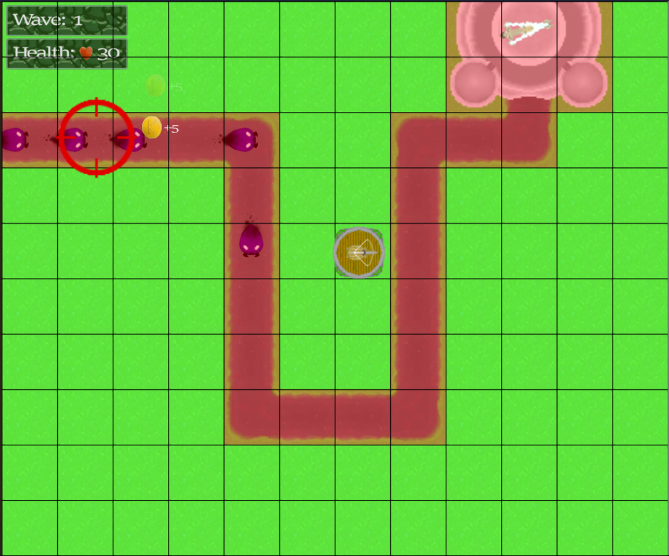

Figure 8

The shop script is added and works well, and to keep the tempo on the shop system going I created the UI for it as well. The UI is made exactly like I had it in mind when I made the concept (figure 9).

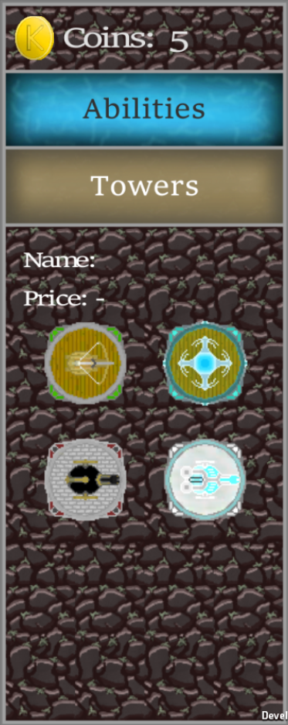 Figure 9

## Dynamics

The range of a tower is added as a circle around the tower, this allows the player to strategically place the towers on the map. (Figure 5)

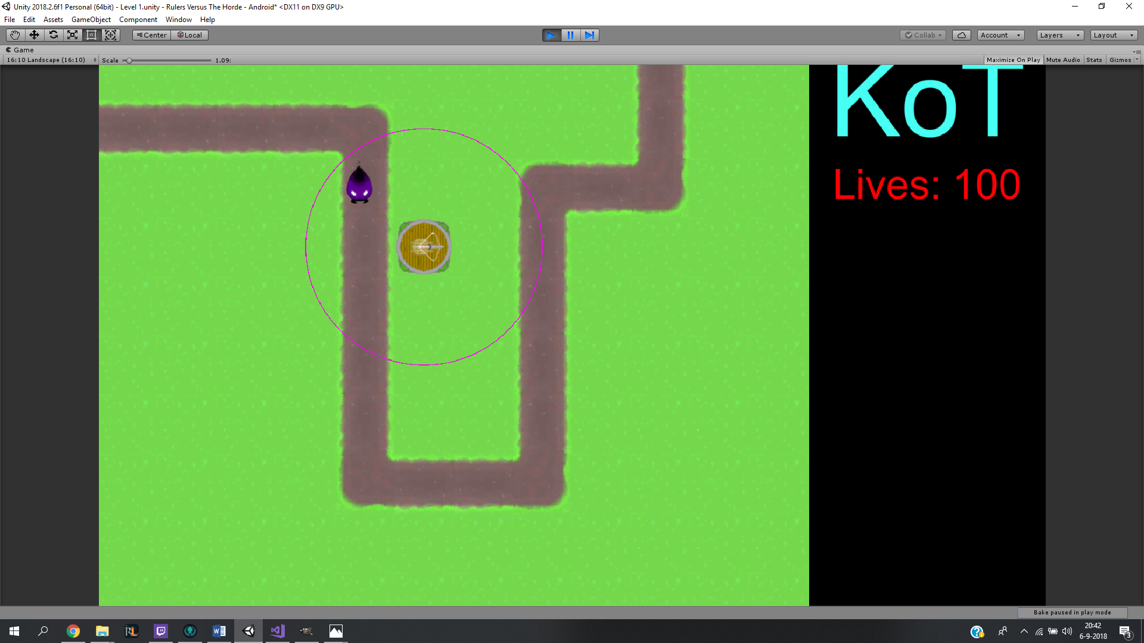

Figure 5

## Aesthetics

Since the mobs and towers needed sprites, I made the sprites for the mobs and towers using GIMP. There are also no map tiles so those were made as well (Figure 7).

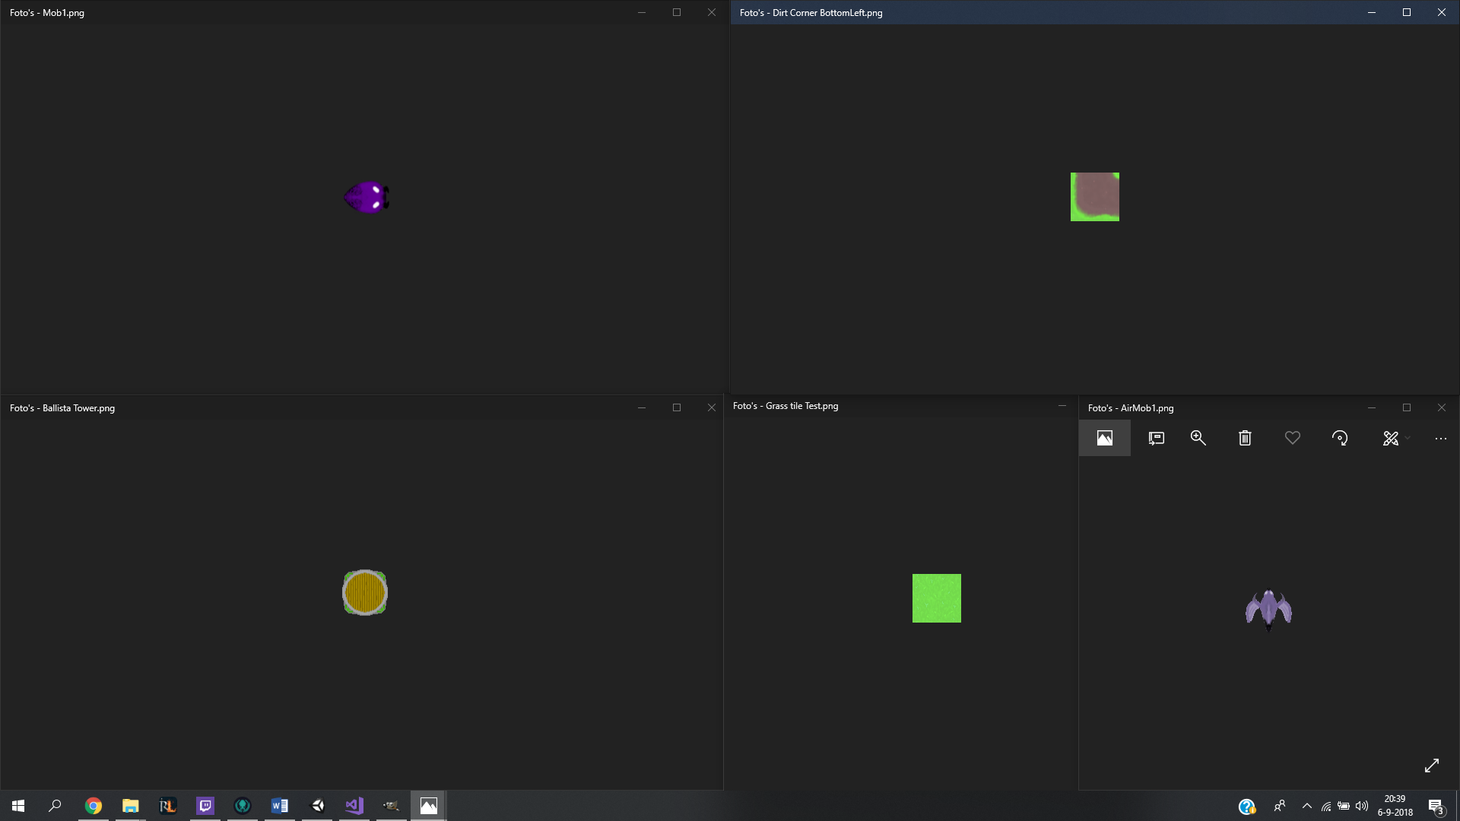

Figure 7

The map was designed and made by Tim. The layout is simple yet shows that the mobs have a route that they follow (Figure 10).

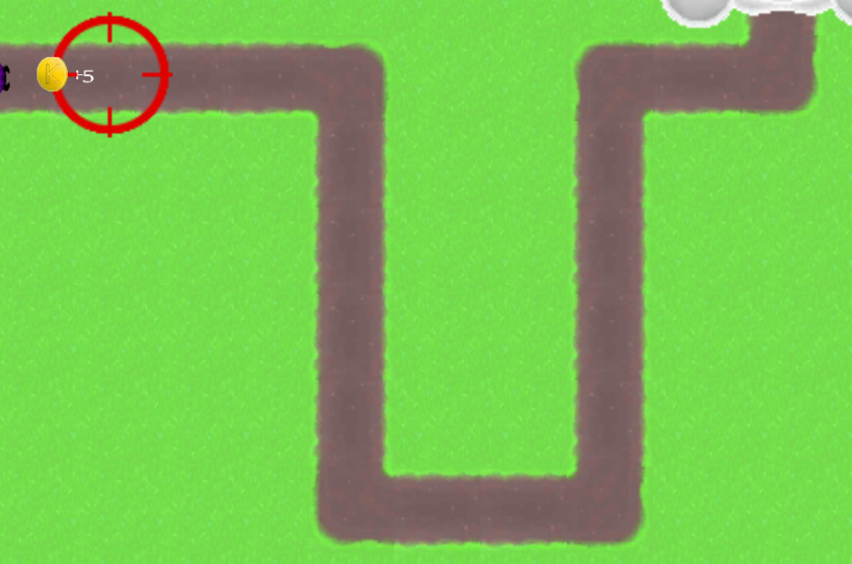

Figure 10

# Fase 3 – Deliverable

In this fase Tim decided he would not be continuing GameDesign, leaving Damian alone to work on the game.

Feedback from the low fidelity showed me flaws in the game, and this feedback caused me to rethink my plan for the coming weeks. I decided to focus more on what is currently in the game and to improve on it, instead of adding more game aspects.

## Mechanics

The upgrade tab is added to the game (Figure 11 – Right side). The upgrade tab took a lot of inspiration from the Bloons upgrade tab (Figure 11 – Left side).

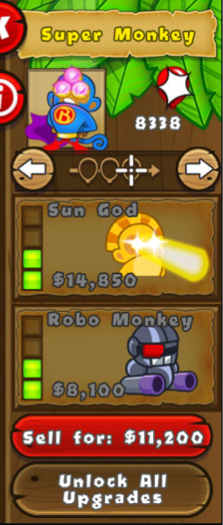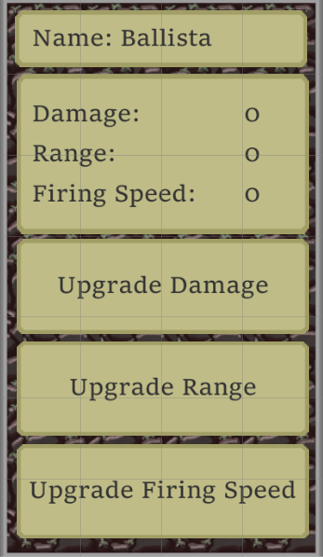

Figure 11

I decided to remove the crystala aspect of the game, because of 2 reasons:

1. The Crystala mechanic breaks the point of having a maximum amount of waves, because the only way to win the game is to get a certain amount of Crystala.
2. The mechanic and generator take a while to create and set up, and because I am working alone now I need to focus on other priorities.

Feedback told me I needed to show that my class diagram works, and that it is easy for me to add towers and mobs. To show this is added 3 new towers and 1 new mob.

The mage tower (Figure 17) can only attack air and mage mobs, this improves the game’s dynamics as well because it now adds a new layer of strategy to the game.

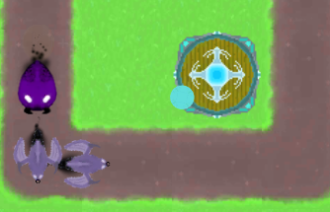

Figure 17

The bomb tower (Figure 18) can only damage ground type mobs, but when the projectile of the bomb tower explodes all mobs in the vicinity of the bomb will take damage. This was added to show that I can also add new types of projectiles to the game with different effects.

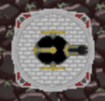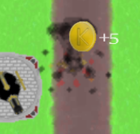

Figure 18

The Freezing tower (Figure 19) was added to make another layer In the dynamics of the game. This tower slows mobs when they get near.

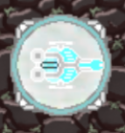

Figure 19

The new mob (Figure 20) that was added is a mage type, and the existing 2 mobs were given the air and ground type. This is so that the type mechanic of the game is now fully in place and working.

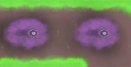

Figure 20

## Dynamics

A major feedback point was that the player jumps into the game too quickly. Therefore I added the tutorial to the first level, to give the player some breathing room when the level starts, and to give a quick introduction to the player to the game. (Figure 22)

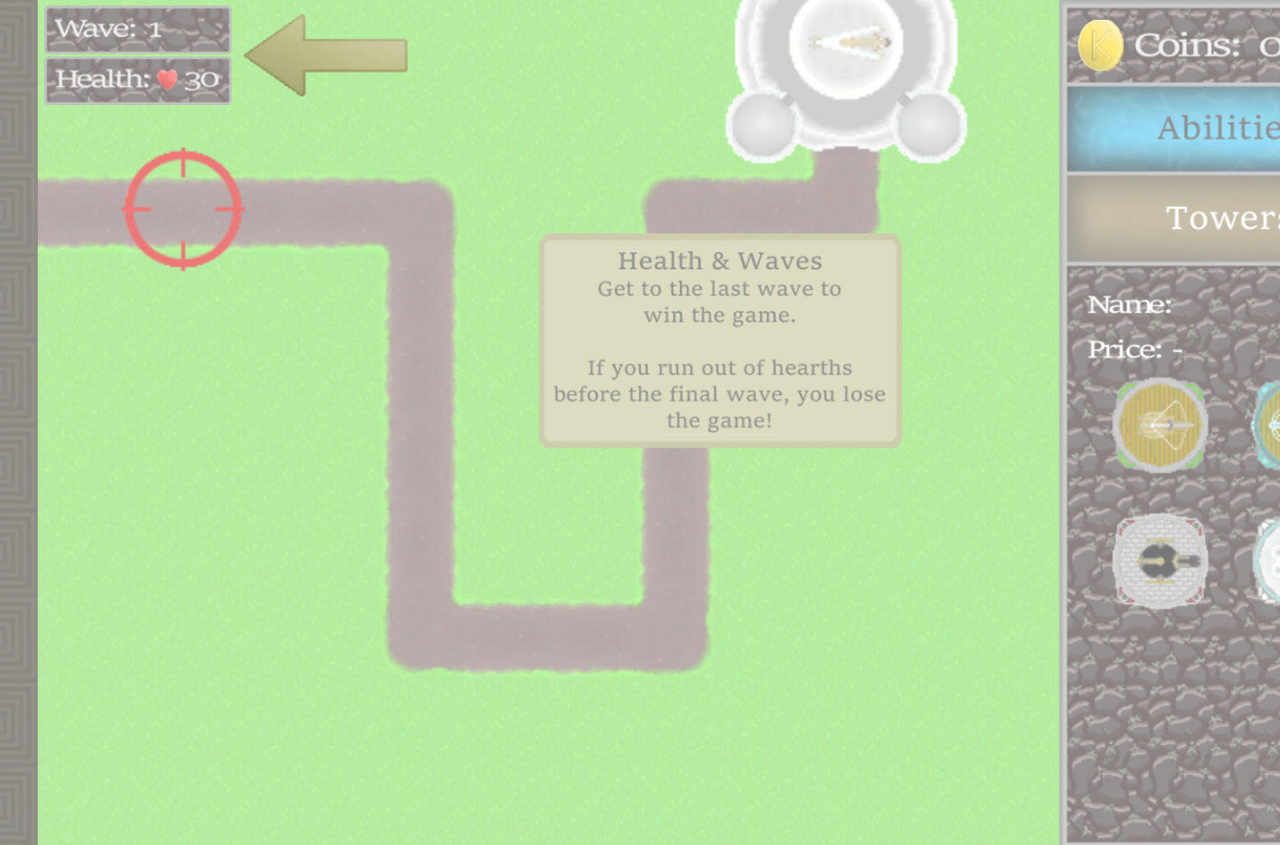

Figure 22

## Aesthetics

I added a visual cue to the upgrade tab for when the player does not have enough gold to upgrade, it gives the player feedback on what they can and cannot do. (Figure 12)

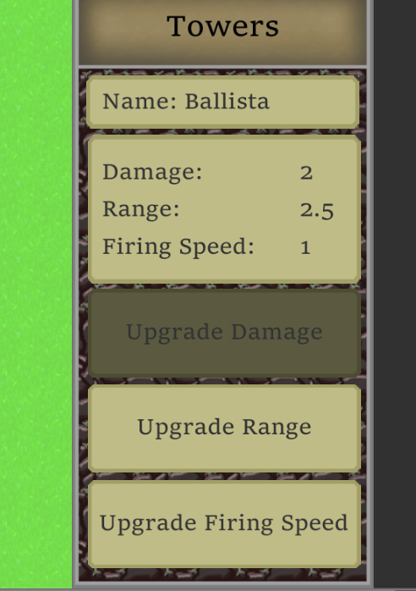

Figure 12

I added feedback on the gaining and losing of gold and hearths. This is because part of the feedback from the low fidelity was that players didn’t know that they were earning gold by killing mobs. (Figure 13)

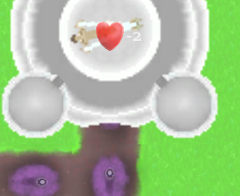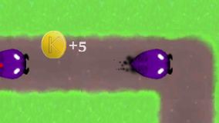

Figure 13

A gold coin and hearth sprite was made in GIMP and added into the game for feedback purposes (Figure 14). The coin was based on the Mario coin. (Figure 15)



Figure 14



Figure 15

To give the player the impression that the mob that is attacked by the freezing tower is actually slowed, I added a blue hue to mobs that are slowed. (Figure 21)

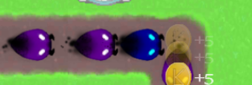

Figure 21

To add to the feedback I also added the coin from figure 14 to the upgrade tab to show the prices better. (Figure 16)

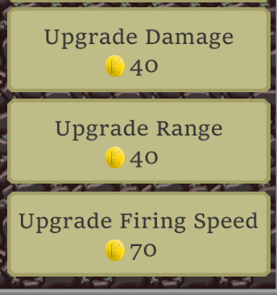

Figure 16

# Sources

Crystala bar tutorial video: <https://www.youtube.com/watch?v=6Z7_ZbNUNw8&t=804s>